CHRISTMAS AT THE CLOUGH 2017

SATURDAY 16TH DECEMBER – SUNDAY 17TH DECEMBER
Children’s parties – Saturday / Sunday
£4.75 per child – includes a packed lunch, games and a visit to see Santa with a gift

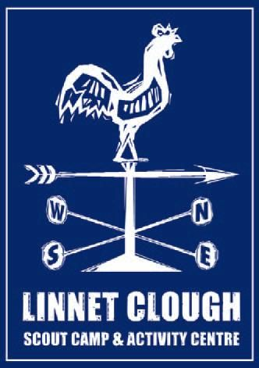
Group: | .....................................................................................................
Name: | ............... .................................................................... .................
Address: | ....................................................................................................
 | ....................................................................................................
 | ....................................................................................................
Telephone: | ....................................................................................................
Email: | ....................................................................................................

CHILDREN’S CHRISTMAS PARTIES – Saturday 16th & Sunday 17th December
Cost £4.75 per head, includes refreshments and present from Father Christmas
Saturday 16th December |  |  |  | Sunday 17th December
TIME | NUMBER OF PLACES REQUIRED  Boys/Girls |  |  | TIME | NUMBER OF PLACES REQUIRED  Boys/Girls
10.30-12.30 |  |  |  | 10.30-12.30
13.00-15.00 |  |  |  | 13.00-15.00
15.30-17.30 |  |  |  | 15.30-17.30

A £1.50 per head non-returnable deposit must be paid at the time of booking. The balance must be paid by 1st December.

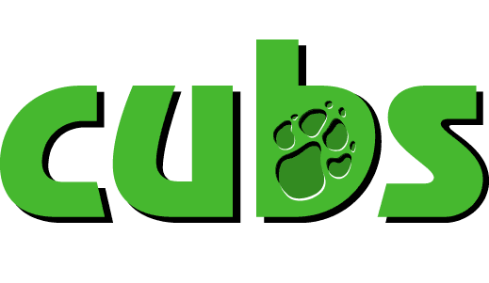
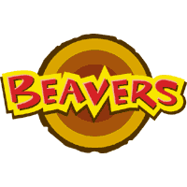
Places for each party are limited and please note that due to problems in the past places will only be allocated on receipt of deposit. If possible please give a second option if the preferred party time is already fully allocated.

